Ex1:
OrmLearnApplication.java
package com.cognizant.orm_learn;

import com.cognizant.orm_learn.service.CountryService;
import org.springframework.boot.SpringApplication;
import org.springframework.boot.autoconfigure.SpringBootApplication;
import org.springframework.context.ApplicationContext;

@SpringBootApplication
public class OrmLearnApplication {

private static CountryService countryService;

public static void main(String[] args) {

ApplicationContext context =
SpringApplication.run(OrmLearnApplication.class, args);

countryService = context.getBean(CountryService.class);

testSearchContaining();

testSearchContainingSorted();

testSearchStartingWith();
}

private static void testSearchContaining() {

System.out.println("Countries containing 'ou'");

System.out.println(countryService.searchCountries("ou"));

System.out.println();
}

private static void testSearchContainingSorted() {

System.out.println("Countries containing 'ou' sorted");

System.out.println(countryService.searchCountriesSorted("ou"));

System.out.println();
}

private static void testSearchStartingWith() {

System.out.println("Countries starting with Z");

System.out.println(countryService.searchCountriesStartingWith("Z"));
}
}
CountryService.java
package com.cognizant.orm_learn.service;

import com.cognizant.orm_learn.model.Country;
import com.cognizant.orm_learn.repository.CountryRepository;
import org.springframework.beans.factory.annotation.Autowired;
import org.springframework.stereotype.Service;
import org.springframework.transaction.annotation.Transactional;

import java.util.List;

@Service
public class CountryService {

@Autowired
private CountryRepository countryRepository;

@Transactional
public List<Country> searchCountries(String text) {
return countryRepository.findByNameContaining(text);
}

@Transactional
public List<Country> searchCountriesSorted(String text) {
return countryRepository.findByNameContainingOrderByNameAsc(text);
}

@Transactional
public List<Country> searchCountriesStartingWith(String alphabet) {
return countryRepository.findByNameStartingWith(alphabet);
}
}
CountryRepository.java
package com.cognizant.orm_learn.repository;

import com.cognizant.orm_learn.model.Country;
import org.springframework.data.jpa.repository.JpaRepository;
import org.springframework.stereotype.Repository;

import java.util.List;

@Repository
public interface CountryRepository extends JpaRepository<Country, String> {

List<Country> findByNameContaining(String text);

List<Country> findByNameContainingOrderByNameAsc(String text);

List<Country> findByNameStartingWith(String alphabet);
}
Country.java
package com.cognizant.orm_learn.model;

import jakarta.persistence.Column;
import jakarta.persistence.Entity;
import jakarta.persistence.Id;
import jakarta.persistence.Table;

@Entity
@Table(name = "country")
public class Country {

@Id
@Column(name = "co_code")
private String code;

@Column(name = "co_name")
private String name;

public Country() {
}

public Country(String code, String name) {
this.code = code;
this.name = name;
}

public String getCode() {
return code;
}

public void setCode(String code) {
this.code = code;
}

public String getName() {
return name;
}

public void setName(String name) {
this.name = name;
}

@Override
public String toString() {
return "Country{" +
"code='" + code + '\'' +
", name='" + name + '\'' +
'}';
}
}
Data.sql
INSERT INTO country VALUES ('IN','India');
INSERT INTO country VALUES ('US','United States of America');
INSERT INTO country VALUES ('ZA','South Africa');
INSERT INTO country VALUES ('ZM','Zambia');
INSERT INTO country VALUES ('ZW','Zimbabwe');
INSERT INTO country VALUES ('LU','Luxembourg');
INSERT INTO country VALUES ('DJ','Djibouti');
INSERT INTO country VALUES ('BV','Bouvet Island');
INSERT INTO country VALUES ('TF','French Southern Territories');
INSERT INTO country VALUES ('UM','United States Minor Outlying Islands');
INSERT INTO country VALUES ('GS','South Georgia and the South Sandwich Islands');
INSERT INTO country VALUES ('SS','South Sudan');
INSERT INTO country VALUES ('GP','Guadeloupe');
Schema.sql
CREATE TABLE country(
co_code VARCHAR(2) PRIMARY KEY,
co_name VARCHAR(50)
);
Application.properties
spring.application.name=orm-learn

spring.datasource.url=jdbc:h2:mem:ormlearn
spring.datasource.driverClassName=org.h2.Driver
spring.datasource.username=sa
spring.datasource.password=password

spring.jpa.database-platform=org.hibernate.dialect.H2Dialect
spring.jpa.hibernate.ddl-auto=none

spring.h2.console.enabled=true
spring.h2.console.path=/h2-console

spring.sql.init.mode=always

logging.level.org.springframework=INFO
logging.level.com.cognizant=DEBUG
logging.level.org.hibernate.SQL=DEBUG

spring.h2.console.enabled=true
spring.h2.console.path=/h2-console
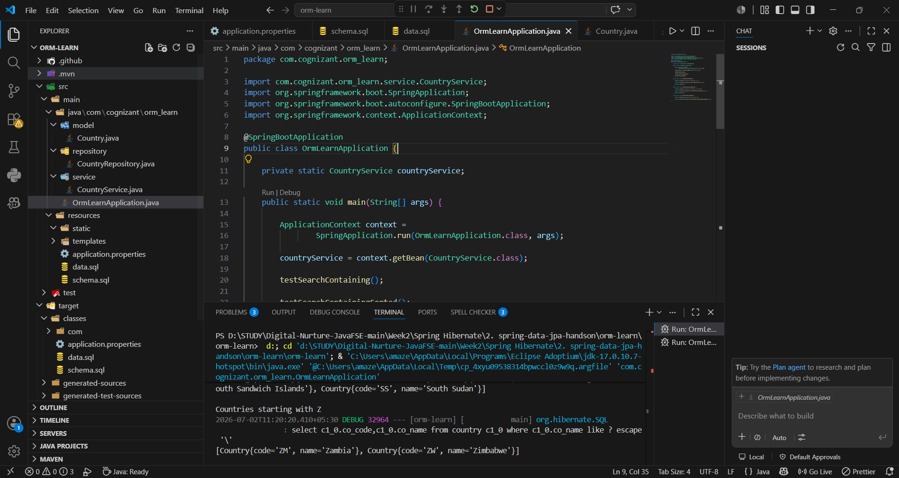

Ex2:
OrmLearnApplication.java
package com.cognizant.orm_learn;

import com.cognizant.orm_learn.repository.StockRepository;
import org.springframework.boot.SpringApplication;
import org.springframework.boot.autoconfigure.SpringBootApplication;
import org.springframework.context.ApplicationContext;

import java.time.LocalDate;

@SpringBootApplication
public class OrmLearnApplication {

private static StockRepository stockRepository;

public static void main(String[] args) {

ApplicationContext context =
SpringApplication.run(OrmLearnApplication.class, args);

stockRepository = context.getBean(StockRepository.class);

testFacebookStocks();

testGoogleStocks();

testHighestVolume();

testNetflixLowest();
}

private static void testFacebookStocks() {

System.out.println("\nFacebook Stocks (September 2019)");

System.out.println(
stockRepository.findByCodeAndDateBetween(
"FB",
LocalDate.of(2019, 9, 1),
LocalDate.of(2019, 9, 30)
)
);
}

private static void testGoogleStocks() {

System.out.println("\nGoogle Stocks > 1250");

System.out.println(
stockRepository.findByCodeAndCloseGreaterThan(
"GOOGL",
1250
)
);
}

private static void testHighestVolume() {

System.out.println("\nTop 3 Highest Volume");

System.out.println(
stockRepository.findTop3ByOrderByVolumeDesc()
);
}

private static void testNetflixLowest() {

System.out.println("\nLowest 3 Netflix Stocks");

System.out.println(
stockRepository.findTop3ByCodeOrderByCloseAsc("NFLX")
);
}
}
Stock.java
package com.cognizant.orm_learn.model;

import jakarta.persistence.*;
import java.time.LocalDate;

@Entity
@Table(name = "stock")
public class Stock {

@Id
@GeneratedValue(strategy = GenerationType.IDENTITY)
@Column(name="st_id")
private Integer id;

@Column(name="st_code")
private String code;

@Column(name="st_date")
private LocalDate date;

@Column(name="st_open")
private double open;

@Column(name="st_close")
private double close;

@Column(name="st_volume")
private long volume;

public Integer getId() {
return id;
}

public void setId(Integer id) {
this.id = id;
}

public String getCode() {
return code;
}

public void setCode(String code) {
this.code = code;
}

public LocalDate getDate() {
return date;
}

public void setDate(LocalDate date) {
this.date = date;
}

public double getOpen() {
return open;
}

public void setOpen(double open) {
this.open = open;
}

public double getClose() {
return close;
}

public void setClose(double close) {
this.close = close;
}

public long getVolume() {
return volume;
}

public void setVolume(long volume) {
this.volume = volume;
}

@Override
public String toString() {
return "Stock{" +
"code='" + code + '\'' +
", date=" + date +
", open=" + open +
", close=" + close +
", volume=" + volume +
'}';
}
}
StockRepository.java
package com.cognizant.orm_learn.repository;

import com.cognizant.orm_learn.model.Stock;
import org.springframework.data.jpa.repository.JpaRepository;

import java.time.LocalDate;
import java.util.List;

public interface StockRepository extends JpaRepository<Stock,Integer> {

List<Stock> findByCodeAndDateBetween(
String code,
LocalDate start,
LocalDate end);

List<Stock> findByCodeAndCloseGreaterThan(
String code,
double price);

List<Stock> findTop3ByOrderByVolumeDesc();

List<Stock> findTop3ByCodeOrderByCloseAsc(
String code);
}
Schema.sql
CREATE TABLE country(
co_code VARCHAR(2) PRIMARY KEY,
co_name VARCHAR(50)
);

CREATE TABLE stock(
st_id INT AUTO_INCREMENT PRIMARY KEY,
st_code VARCHAR(10),
st_date DATE,
st_open DECIMAL(10,2),
st_close DECIMAL(10,2),
st_volume BIGINT
);
Data.sql
INSERT INTO country VALUES ('IN','India');
INSERT INTO country VALUES ('US','United States of America');
INSERT INTO country VALUES ('ZA','South Africa');
INSERT INTO country VALUES ('ZM','Zambia');
INSERT INTO country VALUES ('ZW','Zimbabwe');
INSERT INTO country VALUES ('LU','Luxembourg');
INSERT INTO country VALUES ('DJ','Djibouti');
INSERT INTO country VALUES ('BV','Bouvet Island');
INSERT INTO country VALUES ('TF','French Southern Territories');
INSERT INTO country VALUES ('UM','United States Minor Outlying Islands');
INSERT INTO country VALUES ('GS','South Georgia and the South Sandwich Islands');
INSERT INTO country VALUES ('SS','South Sudan');
INSERT INTO country VALUES ('GP','Guadeloupe');

INSERT INTO stock(st_code,st_date,st_open,st_close,st_volume) VALUES
('FB','2019-09-03',184.00,182.39,9779400),
('FB','2019-09-10',187.44,186.17,15455900),
('FB','2019-09-20',190.66,189.93,19934200),

('GOOGL','2019-04-22',1236.67,1253.76,954200),
('GOOGL','2019-04-23',1256.64,1270.59,1593400),
('GOOGL','2019-10-17',1251.40,1252.80,1047900),

('NFLX','2018-12-24',242.00,233.88,9547600),
('NFLX','2018-12-21',263.83,246.39,21397600),
('NFLX','2018-12-26',233.92,253.67,14402700);
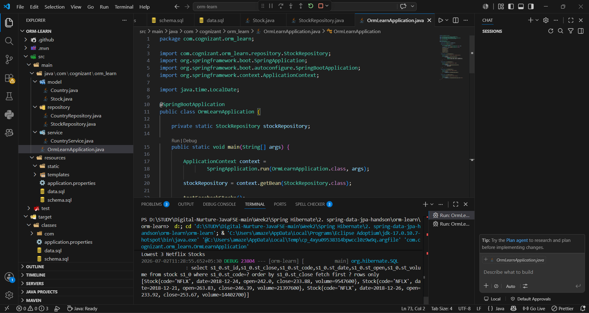

Ex3:
Department.java
package com.cognizant.orm_learn.model;

import jakarta.persistence.*;

@Entity
@Table(name = "department")
public class Department {

@Id
@GeneratedValue(strategy = GenerationType.IDENTITY)
@Column(name = "dp_id")
private int id;

@Column(name = "dp_name")
private String name;

public int getId() {
return id;
}

public void setId(int id) {
this.id = id;
}

public String getName() {
return name;
}

public void setName(String name) {
this.name = name;
}

@Override
public String toString() {
return "Department{id=" + id +
", name='" + name + "'}";
}
}
Employee.java
package com.cognizant.orm_learn.model;

import jakarta.persistence.*;

import java.util.Date;

@Entity
@Table(name = "employee")
public class Employee {

@Id
@GeneratedValue(strategy = GenerationType.IDENTITY)
@Column(name = "em_id")
private int id;

@Column(name = "em_name")
private String name;

@Column(name = "em_salary")
private double salary;

@Column(name = "em_permanent")
private boolean permanent;

@Temporal(TemporalType.DATE)
@Column(name = "em_date_of_birth")
private Date dateOfBirth;

public int getId() {
return id;
}

public void setId(int id) {
this.id = id;
}

public String getName() {
return name;
}

public void setName(String name) {
this.name = name;
}

public double getSalary() {
return salary;
}

public void setSalary(double salary) {
this.salary = salary;
}

public boolean isPermanent() {
return permanent;
}

public void setPermanent(boolean permanent) {
this.permanent = permanent;
}

public Date getDateOfBirth() {
return dateOfBirth;
}

public void setDateOfBirth(Date dateOfBirth) {
this.dateOfBirth = dateOfBirth;
}

@Override
public String toString() {
return "Employee{id=" + id +
", name='" + name + "'}";
}
}
Skill.java
package com.cognizant.orm_learn.model;

import jakarta.persistence.*;

@Entity
@Table(name = "skill")
public class Skill {

@Id
@GeneratedValue(strategy = GenerationType.IDENTITY)
@Column(name = "sk_id")
private int id;

@Column(name = "sk_name")
private String name;

public int getId() {
return id;
}

public void setId(int id) {
this.id = id;
}

public String getName() {
return name;
}

public void setName(String name) {
this.name = name;
}

@Override
public String toString() {
return "Skill{id=" + id +
", name='" + name + "'}";
}
}
DepartmentRepository.java
package com.cognizant.orm_learn.repository;

import com.cognizant.orm_learn.model.Department;
import org.springframework.data.jpa.repository.JpaRepository;
import org.springframework.stereotype.Repository;

@Repository
public interface DepartmentRepository extends JpaRepository<Department, Integer> {
}
EmployeeRepository.java
package com.cognizant.orm_learn.repository;

import com.cognizant.orm_learn.model.Employee;
import org.springframework.data.jpa.repository.JpaRepository;
import org.springframework.stereotype.Repository;

@Repository
public interface EmployeeRepository extends JpaRepository<Employee, Integer> {
}
SkillRepository.java
package com.cognizant.orm_learn.repository;

import com.cognizant.orm_learn.model.Skill;
import org.springframework.data.jpa.repository.JpaRepository;
import org.springframework.stereotype.Repository;

@Repository
public interface SkillRepository extends JpaRepository<Skill, Integer> {
}
Schema.sql
CREATE TABLE country(
co_code VARCHAR(2) PRIMARY KEY,
co_name VARCHAR(50)
);

CREATE TABLE stock(
st_id INT AUTO_INCREMENT PRIMARY KEY,
st_code VARCHAR(10),
st_date DATE,
st_open DECIMAL(10,2),
st_close DECIMAL(10,2),
st_volume BIGINT
);

CREATE TABLE department(
dp_id INT AUTO_INCREMENT PRIMARY KEY,
dp_name VARCHAR(50)
);

CREATE TABLE employee(
em_id INT AUTO_INCREMENT PRIMARY KEY,
em_name VARCHAR(50),
em_salary DOUBLE,
em_permanent BOOLEAN,
em_date_of_birth DATE,
em_dp_id INT,
FOREIGN KEY (em_dp_id) REFERENCES department(dp_id)
);

CREATE TABLE skill(
sk_id INT AUTO_INCREMENT PRIMARY KEY,
sk_name VARCHAR(50)
);

CREATE TABLE employee_skill(
es_em_id INT,
es_sk_id INT,
PRIMARY KEY(es_em_id, es_sk_id),
FOREIGN KEY(es_em_id) REFERENCES employee(em_id),
FOREIGN KEY(es_sk_id) REFERENCES skill(sk_id)
);
Data.sql
INSERT INTO country VALUES ('IN','India');
INSERT INTO country VALUES ('US','United States of America');
INSERT INTO country VALUES ('ZA','South Africa');
INSERT INTO country VALUES ('ZM','Zambia');
INSERT INTO country VALUES ('ZW','Zimbabwe');
INSERT INTO country VALUES ('LU','Luxembourg');
INSERT INTO country VALUES ('DJ','Djibouti');
INSERT INTO country VALUES ('BV','Bouvet Island');
INSERT INTO country VALUES ('TF','French Southern Territories');
INSERT INTO country VALUES ('UM','United States Minor Outlying Islands');
INSERT INTO country VALUES ('GS','South Georgia and the South Sandwich Islands');
INSERT INTO country VALUES ('SS','South Sudan');
INSERT INTO country VALUES ('GP','Guadeloupe');

INSERT INTO stock(st_code,st_date,st_open,st_close,st_volume) VALUES
('FB','2019-09-03',184.00,182.39,9779400),
('FB','2019-09-10',187.44,186.17,15455900),
('FB','2019-09-20',190.66,189.93,19934200),

('GOOGL','2019-04-22',1236.67,1253.76,954200),
('GOOGL','2019-04-23',1256.64,1270.59,1593400),
('GOOGL','2019-10-17',1251.40,1252.80,1047900),

('NFLX','2018-12-24',242.00,233.88,9547600),
('NFLX','2018-12-21',263.83,246.39,21397600),
('NFLX','2018-12-26',233.92,253.67,14402700);

INSERT INTO department(dp_name)
VALUES
('IT'),
('HR');

INSERT INTO employee(em_name, em_salary, em_permanent, em_date_of_birth, em_dp_id)
VALUES
('John',50000,true,'1998-05-10',1),
('Alice',60000,true,'1997-09-15',1),
('Bob',45000,false,'2000-01-20',2);

INSERT INTO skill(sk_name)
VALUES
('Java'),
('Spring'),
('SQL');

INSERT INTO employee_skill
VALUES
(1,1),
(1,2),
(2,2),
(2,3),
(3,3);
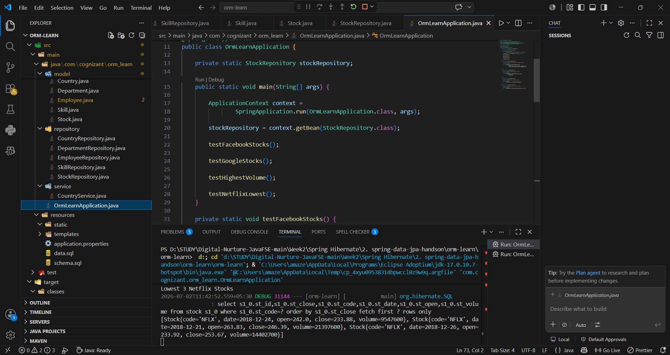

Ex4:
OrmLearnApplication.java
package com.cognizant.orm_learn;

import com.cognizant.orm_learn.model.Employee;
import com.cognizant.orm_learn.service.CountryService;
import com.cognizant.orm_learn.service.DepartmentService;
import com.cognizant.orm_learn.service.EmployeeService;
import com.cognizant.orm_learn.service.SkillService;
import org.springframework.boot.SpringApplication;
import org.springframework.boot.autoconfigure.SpringBootApplication;
import org.springframework.context.ApplicationContext;

@SpringBootApplication
public class OrmLearnApplication {

private static CountryService countryService;
private static EmployeeService employeeService;
private static DepartmentService departmentService;
private static SkillService skillService;

public static void main(String[] args) {

ApplicationContext context =
SpringApplication.run(OrmLearnApplication.class, args);

countryService = context.getBean(CountryService.class);
employeeService = context.getBean(EmployeeService.class);
departmentService = context.getBean(DepartmentService.class);
skillService = context.getBean(SkillService.class);

// Uncomment ONLY ONE test at a time

testGetEmployee();

// testAddEmployee();

// testUpdateEmployee();
}

private static void testGetEmployee() {

System.out.println("===== GET EMPLOYEE =====");

Employee employee = employeeService.get(1);

System.out.println(employee);
System.out.println(employee.getDepartment());
}

private static void testAddEmployee() {

System.out.println("===== ADD EMPLOYEE =====");

Employee employee = new Employee();

employee.setName("David");
employee.setSalary(70000);
employee.setPermanent(true);
employee.setDateOfBirth(java.sql.Date.valueOf("1999-03-15"));

employee.setDepartment(departmentService.get(1));

employeeService.save(employee);

System.out.println(employee);
}

private static void testUpdateEmployee() {

System.out.println("===== UPDATE EMPLOYEE =====");

Employee employee = employeeService.get(1);

employee.setDepartment(departmentService.get(2));

employeeService.save(employee);

System.out.println(employee);
}
}DepartmentService.java
package com.cognizant.orm_learn.service;

import com.cognizant.orm_learn.model.Department;
import com.cognizant.orm_learn.repository.DepartmentRepository;
import org.springframework.beans.factory.annotation.Autowired;
import org.springframework.stereotype.Service;
import org.springframework.transaction.annotation.Transactional;

@Service
public class DepartmentService {

@Autowired
private DepartmentRepository departmentRepository;

@Transactional
public Department get(int id) {
return departmentRepository.findById(id).get();
}

@Transactional
public void save(Department department) {
departmentRepository.save(department);
}
}

EmployeeService.java
package com.cognizant.orm_learn.service;

import com.cognizant.orm_learn.model.Employee;
import com.cognizant.orm_learn.repository.EmployeeRepository;
import org.springframework.beans.factory.annotation.Autowired;
import org.springframework.stereotype.Service;
import org.springframework.transaction.annotation.Transactional;

@Service
public class EmployeeService {

@Autowired
private EmployeeRepository employeeRepository;

@Transactional
public Employee get(int id) {
return employeeRepository.findById(id).get();
}

@Transactional
public void save(Employee employee) {
employeeRepository.save(employee);
}
}
SkillService.java
package com.cognizant.orm_learn.service;

import com.cognizant.orm_learn.model.Skill;
import com.cognizant.orm_learn.repository.SkillRepository;
import org.springframework.beans.factory.annotation.Autowired;
import org.springframework.stereotype.Service;
import org.springframework.transaction.annotation.Transactional;

@Service
public class SkillService {

@Autowired
private SkillRepository skillRepository;

@Transactional
public Skill get(int id) {
return skillRepository.findById(id).get();
}

@Transactional
public void save(Skill skill) {
skillRepository.save(skill);
}
}
Employee.java
package com.cognizant.orm_learn.model;

import jakarta.persistence.*;

import java.util.Date;

@Entity
@Table(name = "employee")
public class Employee {

@Id
@GeneratedValue(strategy = GenerationType.IDENTITY)
@Column(name = "em_id")
private int id;

@Column(name = "em_name")
private String name;

@Column(name = "em_salary")
private double salary;

@Column(name = "em_permanent")
private boolean permanent;

@Temporal(TemporalType.DATE)
@Column(name = "em_date_of_birth")
private Date dateOfBirth;

public int getId() {
return id;
}

public void setId(int id) {
this.id = id;
}

public String getName() {
return name;
}

public void setName(String name) {
this.name = name;
}

public double getSalary() {
return salary;
}

public void setSalary(double salary) {
this.salary = salary;
}

public boolean isPermanent() {
return permanent;
}

public void setPermanent(boolean permanent) {
this.permanent = permanent;
}

public Date getDateOfBirth() {
return dateOfBirth;
}

public void setDateOfBirth(Date dateOfBirth) {
this.dateOfBirth = dateOfBirth;
}
@ManyToOne
@JoinColumn(name = "em_dp_id")
private Department department;
public Department getDepartment() {
return department;
}

public void setDepartment(Department department) {
this.department = department;
}

@Override
public String toString() {
return "Employee{id=" + id +
", name='" + name + "'}";
}
}
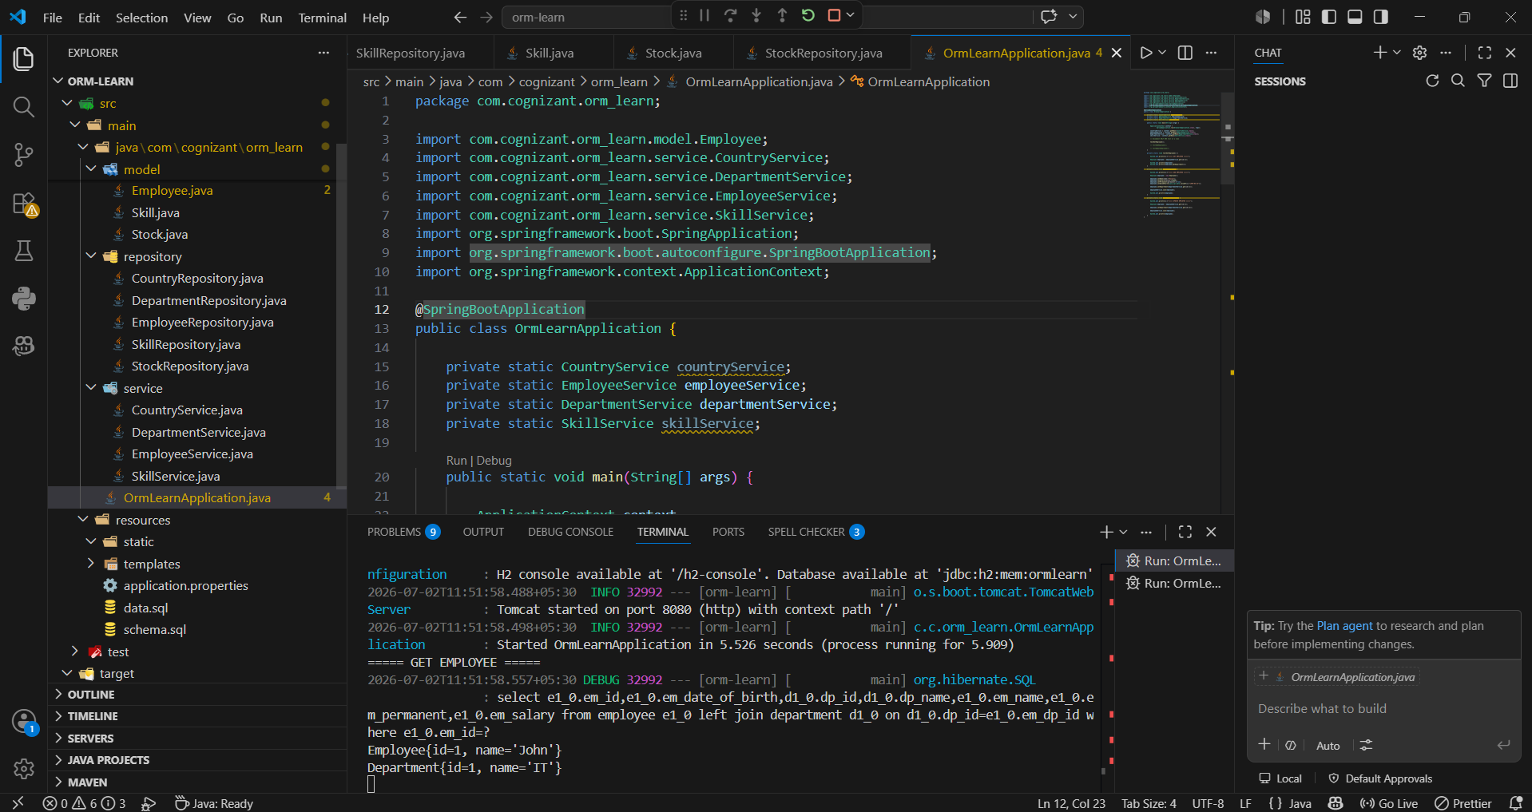

Ex5:
OrmLearnApplication.java
package com.cognizant.orm_learn;

import com.cognizant.orm_learn.model.Department;
import com.cognizant.orm_learn.service.DepartmentService;
import com.cognizant.orm_learn.service.EmployeeService;
import com.cognizant.orm_learn.service.SkillService;
import org.springframework.boot.SpringApplication;
import org.springframework.boot.autoconfigure.SpringBootApplication;
import org.springframework.context.ApplicationContext;

@SpringBootApplication
public class OrmLearnApplication {

private static EmployeeService employeeService;
private static DepartmentService departmentService;
private static SkillService skillService;

public static void main(String[] args) {

ApplicationContext context =
SpringApplication.run(OrmLearnApplication.class, args);

employeeService = context.getBean(EmployeeService.class);
departmentService = context.getBean(DepartmentService.class);
skillService = context.getBean(SkillService.class);

testGetDepartment();
}

private static void testGetDepartment() {

Department department = departmentService.get(1);

System.out.println("Department:");
System.out.println(department);

System.out.println();

System.out.println("Employees:");

department.getEmployeeList().forEach(System.out::println);
}
}
Department.java
package com.cognizant.orm_learn.model;

import jakarta.persistence.*;
import java.util.Set;

@Entity
@Table(name = "department")
public class Department {

@Id
@GeneratedValue(strategy = GenerationType.IDENTITY)
@Column(name = "dp_id")
private int id;

@Column(name = "dp_name")
private String name;

@OneToMany(mappedBy = "department", fetch = FetchType.EAGER)
private Set<Employee> employeeList;

public int getId() {
return id;
}

public void setId(int id) {
this.id = id;
}

public String getName() {
return name;
}

public void setName(String name) {
this.name = name;
}

public Set<Employee> getEmployeeList() {
return employeeList;
}

public void setEmployeeList(Set<Employee> employeeList) {
this.employeeList = employeeList;
}

@Override
public String toString() {
return "Department{" +
"id=" + id +
", name='" + name + '\'' +
'}';
}
}
DepartmentService.java
package com.cognizant.orm_learn.service;

import com.cognizant.orm_learn.model.Department;
import com.cognizant.orm_learn.repository.DepartmentRepository;
import jakarta.transaction.Transactional;
import org.springframework.beans.factory.annotation.Autowired;
import org.springframework.stereotype.Service;

@Service
public class DepartmentService {

@Autowired
private DepartmentRepository departmentRepository;

@Transactional
public Department get(int id) {
return departmentRepository.findById(id).get();
}

@Transactional
public void save(Department department) {
departmentRepository.save(department);
}
}
DepartmentRepository.java
package com.cognizant.orm_learn.repository;

import com.cognizant.orm_learn.model.Department;
import org.springframework.data.jpa.repository.JpaRepository;
import org.springframework.stereotype.Repository;

@Repository
public interface DepartmentRepository extends JpaRepository<Department, Integer> {

}
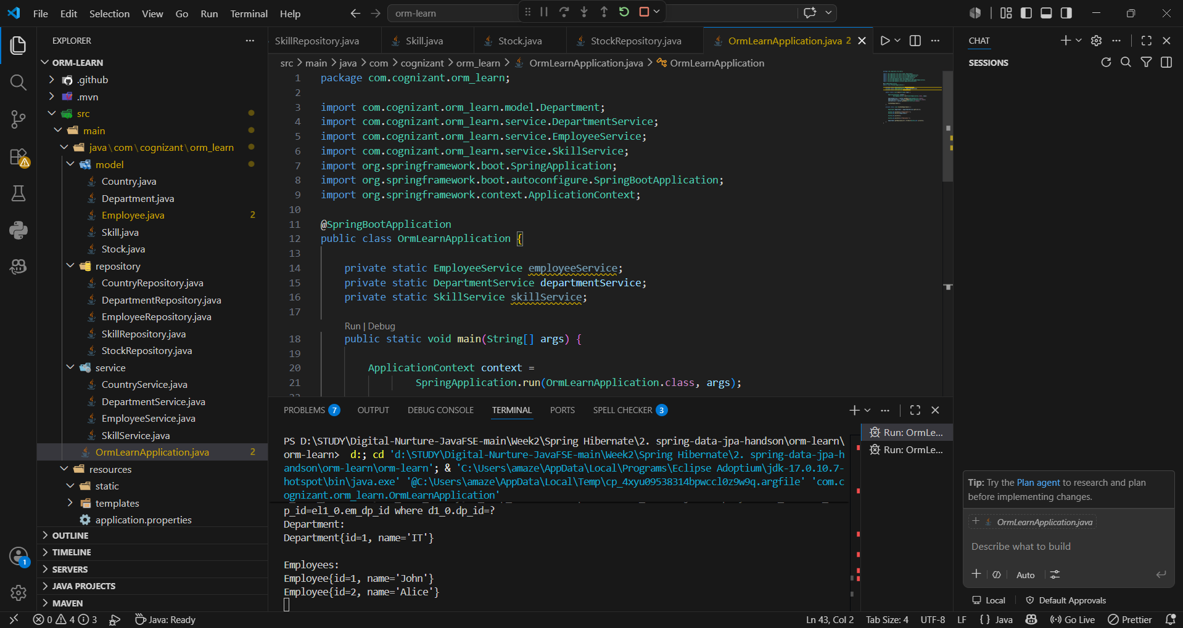

Ex6:
OrmLearnApplication.java
package com.cognizant.orm_learn;

import com.cognizant.orm_learn.model.Employee;
import com.cognizant.orm_learn.model.Skill;
import com.cognizant.orm_learn.service.DepartmentService;
import com.cognizant.orm_learn.service.EmployeeService;
import com.cognizant.orm_learn.service.SkillService;
import org.springframework.boot.SpringApplication;
import org.springframework.boot.autoconfigure.SpringBootApplication;
import org.springframework.context.ApplicationContext;

@SpringBootApplication
public class OrmLearnApplication {

private static EmployeeService employeeService;
private static DepartmentService departmentService;
private static SkillService skillService;

public static void main(String[] args) {

ApplicationContext context =
SpringApplication.run(OrmLearnApplication.class, args);

employeeService = context.getBean(EmployeeService.class);
departmentService = context.getBean(DepartmentService.class);
skillService = context.getBean(SkillService.class);

testGetEmployee();

// Uncomment this after testing the above
// testAddSkillToEmployee();
}

private static void testGetEmployee() {

Employee employee = employeeService.get(1);

System.out.println("Employee:");
System.out.println(employee);

System.out.println();

System.out.println("Department:");
System.out.println(employee.getDepartment());

System.out.println();

System.out.println("Skills:");
employee.getSkillList().forEach(System.out::println);
}

private static void testAddSkillToEmployee() {

Employee employee = employeeService.get(3);

Skill skill = skillService.get(1);

employee.getSkillList().add(skill);

employeeService.save(employee);

System.out.println("Skill Added Successfully!");
}
}
package com.cognizant.orm_learn.model;

import jakarta.persistence.*;
import java.util.Date;
import java.util.Set;

@Entity
@Table(name = "employee")
public class Employee {

@Id
@GeneratedValue(strategy = GenerationType.IDENTITY)
@Column(name = "em_id")
private int id;

@Column(name = "em_name")
private String name;

@Column(name = "em_salary")
private double salary;

@Column(name = "em_permanent")
private boolean permanent;

@Temporal(TemporalType.DATE)
@Column(name = "em_date_of_birth")
private Date dateOfBirth;

@ManyToOne
@JoinColumn(name = "em_dp_id")
private Department department;

@ManyToMany(fetch = FetchType.EAGER)
@JoinTable(
name = "employee_skill",
joinColumns = @JoinColumn(name = "es_em_id"),
inverseJoinColumns = @JoinColumn(name = "es_sk_id")
)
private Set<Skill> skillList;

public int getId() {
return id;
}

public void setId(int id) {
this.id = id;
}

public String getName() {
return name;
}

public void setName(String name) {
this.name = name;
}

public double getSalary() {
return salary;
}

public void setSalary(double salary) {
this.salary = salary;
}

public boolean isPermanent() {
return permanent;
}

public void setPermanent(boolean permanent) {
this.permanent = permanent;
}

public Date getDateOfBirth() {
return dateOfBirth;
}

public void setDateOfBirth(Date dateOfBirth) {
this.dateOfBirth = dateOfBirth;
}

public Department getDepartment() {
return department;
}

public void setDepartment(Department department) {
this.department = department;
}

public Set<Skill> getSkillList() {
return skillList;
}

public void setSkillList(Set<Skill> skillList) {
this.skillList = skillList;
}

@Override
public String toString() {
return "Employee{" +
"id=" + id +
", name='" + name + '\'' +
", salary=" + salary +
", permanent=" + permanent +
", dateOfBirth=" + dateOfBirth +
'}';
}
}
Employee.java
package com.cognizant.orm_learn.model;

import jakarta.persistence.*;
import java.util.Date;
import java.util.Set;

@Entity
@Table(name = "employee")
public class Employee {

@Id
@GeneratedValue(strategy = GenerationType.IDENTITY)
@Column(name = "em_id")
private int id;

@Column(name = "em_name")
private String name;

@Column(name = "em_salary")
private double salary;

@Column(name = "em_permanent")
private boolean permanent;

@Temporal(TemporalType.DATE)
@Column(name = "em_date_of_birth")
private Date dateOfBirth;

@ManyToOne
@JoinColumn(name = "em_dp_id")
private Department department;

@ManyToMany(fetch = FetchType.EAGER)
@JoinTable(
name = "employee_skill",
joinColumns = @JoinColumn(name = "es_em_id"),
inverseJoinColumns = @JoinColumn(name = "es_sk_id")
)
private Set<Skill> skillList;

public int getId() {
return id;
}

public void setId(int id) {
this.id = id;
}

public String getName() {
return name;
}

public void setName(String name) {
this.name = name;
}

public double getSalary() {
return salary;
}

public void setSalary(double salary) {
this.salary = salary;
}

public boolean isPermanent() {
return permanent;
}

public void setPermanent(boolean permanent) {
this.permanent = permanent;
}

public Date getDateOfBirth() {
return dateOfBirth;
}

public void setDateOfBirth(Date dateOfBirth) {
this.dateOfBirth = dateOfBirth;
}

public Department getDepartment() {
return department;
}

public void setDepartment(Department department) {
this.department = department;
}

public Set<Skill> getSkillList() {
return skillList;
}

public void setSkillList(Set<Skill> skillList) {
this.skillList = skillList;
}

@Override
public String toString() {
return "Employee{" +
"id=" + id +
", name='" + name + '\'' +
", salary=" + salary +
", permanent=" + permanent +
", dateOfBirth=" + dateOfBirth +
'}';
}
}
Skill.java
package com.cognizant.orm_learn.model;

import jakarta.persistence.*;
import java.util.Set;

@Entity
@Table(name = "skill")
public class Skill {

@Id
@GeneratedValue(strategy = GenerationType.IDENTITY)
@Column(name = "sk_id")
private int id;

@Column(name = "sk_name")
private String name;

@ManyToMany(mappedBy = "skillList")
private Set<Employee> employeeList;

public int getId() {
return id;
}

public void setId(int id) {
this.id = id;
}

public String getName() {
return name;
}

public void setName(String name) {
this.name = name;
}

public Set<Employee> getEmployeeList() {
return employeeList;
}

public void setEmployeeList(Set<Employee> employeeList) {
this.employeeList = employeeList;
}

@Override
public String toString() {
return "Skill{" +
"id=" + id +
", name='" + name + '\'' +
'}';
}
}
SkillService.java
package com.cognizant.orm_learn.service;

import com.cognizant.orm_learn.model.Skill;
import com.cognizant.orm_learn.repository.SkillRepository;
import jakarta.transaction.Transactional;
import org.springframework.beans.factory.annotation.Autowired;
import org.springframework.stereotype.Service;

@Service
public class SkillService {

@Autowired
private SkillRepository skillRepository;

@Transactional
public Skill get(int id) {
return skillRepository.findById(id).get();
}

@Transactional
public void save(Skill skill) {
skillRepository.save(skill);
}
}
SkillRepository.java
package com.cognizant.orm_learn.repository;

import com.cognizant.orm_learn.model.Skill;
import org.springframework.data.jpa.repository.JpaRepository;
import org.springframework.stereotype.Repository;

@Repository
public interface SkillRepository extends JpaRepository<Skill, Integer> {

}
